Name: Priyanshu Tripathi
Roll number: 12022005

Subject: Java Programming
Code: CSPC-23
Assignment 3

1.
Write a Java program that reads an array of integers and then moves every zero to the right side, i.e., towards the end.
import java.util.Scanner;

public class foobar {
public static void main(String[] args) {
Scanner sc = new Scanner(System.in);
System.out.print("Enter the array starting with its size --> ");
int n = sc.nextInt();

int[] arr = new int[n];
for (int i=0; i < n; i++)
arr[i] = sc.nextInt();

int count = 0;
// Iterates through the given array until it finds a zero
for(int i=0; i < n - 1; i++)
if(arr[i] == 0) {
// Iterates over the rest of the array and shifts
// the elements to the left if they're not zero
for(int j=i; j < n - 1; j++)
if(arr[j+1] != 0)
arr[j - count] = arr[j+1];
else
count++;
count++;
break;
}

// Changes the last few elements to zero depending on `count`
for(int i=n-1; i > (n-1) - count; i--)
arr[i] = 0;

for (int i=0; i < n; i++)
System.out.print(arr[i] + " ");
System.out.println();
}
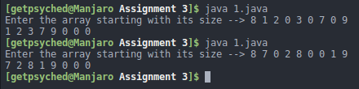
}

2.
Write a Java program to find the k (for given k) largest elements in a given array. Elements in the array can be in any order. Don’t forget to check boundary condition for k.
import java.util.Arrays;
import java.util.Scanner;

public class foobar {
public static void main(String[] args) {
Scanner sc = new Scanner(System.in);
System.out.print("Enter the array starting with its size --> ");
int n = sc.nextInt();

int[] arr = new int[n];
for (int i=0; i < n; i++)
arr[i] = sc.nextInt();

System.out.print("Enter k --> ");
int k = sc.nextInt();
Arrays.sort(arr);

for (int i=0; i < n; i++)
System.out.print(arr[i] + " ");
System.out.println();
}
}
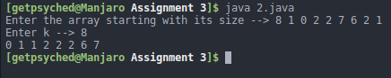

3.
Write a Java program to check if a given positive number is a palindrome or not.
import java.util.Scanner;

public class foobar {
public static void main(String[] args) {
Scanner sc = new Scanner(System.in);
System.out.print("Enter the number --> ");
int n = sc.nextInt();
String num = Integer.toString(n);
int check = 1;
for(int i=0,j=num.length()-1;i<j;i++,j--)
if(num.charAt(i)!=num.charAt(j)) {
check = 0;
break;
}
if(check == 0)
System.out.println("The number is not a palindrome");
else
System.out.println("The number is a Palindrome");

}
}
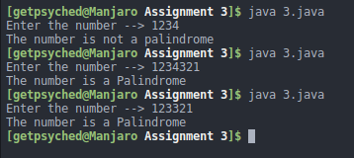

4.
Write a Java program to check if an array of integers contains three increasing adjacent numbers.
import java.util.Scanner;

public class foobar {
public static void main(String[] args) {
Scanner sc = new Scanner(System.in);
System.out.print("Enter the array starting with its size --> ");
int n = sc.nextInt();

int[] arr = new int[n];
for (int i=0; i < n; i++)
arr[i] = sc.nextInt();

int check=1;
for (int i=0; i < n-3; i++)
if(arr[i+1] > arr[i] && arr[i+2] > arr[i+1]) {
System.out.print("Yes it contains 3 adjacent numbers in increasing order");
check=0;
}
if(check == 1)
System.out.print("Three increasing adjacent numbers not found");
}
}
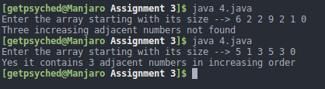

5.
Write a Java program to find the number of integers within the range of two specified
numbers x & y and that are divisible by another number, p.

import java.util.Scanner;

public class foobar {
public static void main(String[] args) {
Scanner sc = new Scanner(System.in);
System.out.print("Enter x, y, p respectively --> ");
int x = sc.nextInt();
int y = sc.nextInt();
int p = sc.nextInt();
int count = 0;
for(int i=x; i <= y; i++)
if(i % p == 0)
count++;
System.out.println("Number of integers between "+x+" and "+y+" which are divisible by "+p+" are "+count);

}
}
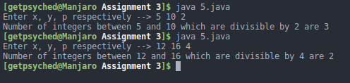

6.
Write a Java program to accept two strings and test if the second string contains the first one.

import java.util.Scanner;

public class foobar {
public static void main(String[] args) {
Scanner sc = new Scanner(System.in);
System.out.print("Enter the First String --> ");
String s1 = sc.nextLine();
System.out.print("Enter the Second String --> ");
String s2 = sc.nextLine();
if(s2.contains(s1))
System.out.println("The second string contains the first string");
else
System.out.println("The second string does not contain the first string");

}
}
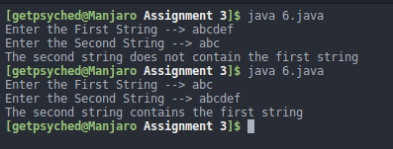

7.
Write a Java program to read two strings from keyboard and compare them lexicographically.

import java.util.Scanner;

public class foobar {
public static void main(String [] args){
System.out.print("Enter first string --> ");
Scanner sc = new Scanner(System.in);
String s1 = sc.nextLine();
System.out.print("Enter second string --> ");
String s2 = sc.nextLine();
int comp = s1.compareTo(s2);
if (comp < 0)
System.out.println("string 1 is greater than string 2");
else if (comp == 0)
System.out.println("string 1 is equal to string 2");
else
System.out.println("string 1 is less than string 2");
}
}
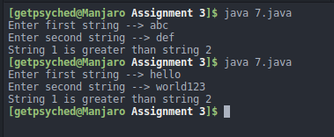

8.
Write a Java program to test if a given string contains the specified sequence of char values.

import java.util.Scanner;

public class foobar {
public static void main(String[] args) {
Scanner sc = new Scanner(System.in);
System.out.print("Enter the first string --> ");
String s1 = sc.nextLine();
System.out.print("Enter the second string --> ");
String s2 = sc.nextLine();
if(s1.contains(s2))
System.out.println("Yes");
else
System.out.println("No");
}
}
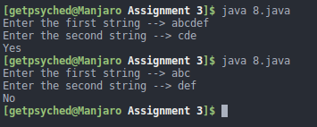

9.
Write a Java program to trim any leading or trailing whitespace from a given string.

import java.util.Scanner;

public class foobar {
public static void main(String[] args) {
Scanner sc = new Scanner(System.in);
System.out.print("Enter the String --> ");
String s1 = sc.nextLine();
System.out.println("Trimmed string is " + s1.trim());
}
}
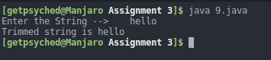

10.
Write a program that reads an arbitrary number of even integers that are in the range 2 to 100 inclusive and counts how many occurrences of each are entered. Indicate the end of the input by entering -1. After entire input has been processed, print all of the values that were entered by the user along with the number of occurrences.

import java.util.Scanner;

public class foobar {
public static void main(String[] args) {
int[] arr = new int[101];
Scanner sc = new Scanner(System.in);
int n = 0;
while(n != -1) {
System.out.print("Enter the number --> ");
n = sc.nextInt();
if(n != -1)
arr[n]++;
}
for(int i=2; i <= 100; i++)
if(i % 2 == 0 && arr[i] != 0) {
System.out.print(i + "->" + arr[i]);
System.out.println();
}
}
}
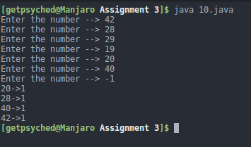

11.
Use a one-dimensional array to solve the following problem:
Write an application that inputs five numbers, each between 10 and 100, inclusive. As each number is read, display it only if it’s not a duplicate of a number already read. Provide for the “worst case” in which all five numbers are different. Use the smallest possible array to solve this problem. Display the complete set of unique values input after the user enters each new value.

import java.util.Scanner;

public class foobar {
public static void main(String[] args) {
Scanner sc = new Scanner(System.in);
int[] arr = new int[5];
int j = -1;
for(int i=0; i < 5; i++) {
System.out.print("Enter the element --> ");
int n = sc.nextInt();
boolean check = false;
for(int k=0; k <= j; k++)
if(arr[k] == n) {
check = true;
break;
}
if(!check)
arr[++j] = n;
for(int x=0; x <= j; x++)
System.out.print(arr[x] + " ");
System.out.println();
}
}
}
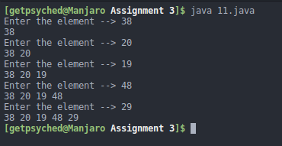

12.
Write a class called NumberOfSixes that represents the total number of sixes hit by an IPL team in a given match. The NumberOfSixes class should contain a single integer as instance data, representing the number of sixes hit. Write a constructor to initialize the number of sixes to zero. Write a method called setSix that increments the value by one whenever a six is hit, and another method called getSix that returns the total number of sixes hit so far. Finally, create a driver class called SixTracker that creates a few NumberOfSixes objects and tests their methods.

import java.util.Random;

public class foobar {
static class NumberOfSixes {
int six;
NumberOfSixes() { six = 0; }
void setSix() { six++; }
int getSix() { return six; }
}

public static void main(String[] args) {
NumberOfSixes obj = new NumberOfSixes();
Random r = new Random();
for(int i=0; i < r.nextInt(10); i++)
obj.setSix();
System.out.println("Total Sixes are " + obj.getSix());
}
}
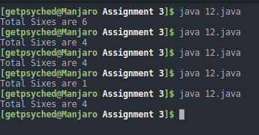

13.
Design and implement a set of classes that define various types of reading material: books, novels, magazines, technical journals, textbooks, and so on. Include data values that describe various attributes of the material, such as the number of pages and the names of the primary characters. Include methods that are named appropriately for each class and that print an appropriate message. Create a main driver class to instantiate and exercise several of the classes.

class ReadingMaterial {
String publication;
int pages;
public ReadingMaterial(String x, int n) {
publication = x;
pages = n;
}
public void print() {
System.out.println("Details of reading material:");
System.out.println("publication: " + this.publication);
System.out.println("No. of pages: " + this.pages);
}
}

class Book extends ReadingMaterial {
public String title, author;
public Book(String title, String author, String publication, int pages) {
super(publication, pages);
this.title = title;
this.author = author;
}
public void print() {
System.out.println("Details of book " + this.title);
System.out.println("Title: " + this.title);
System.out.println("Author: " + this.author);
System.out.println("publication: " + this.publication);
System.out.println("No. of pages: " + this.pages);
}
}

class Novel extends Book {
String genre;
public Novel(String title, String author, String genre, String publication, int pages) {
super(title, author, publication, pages);
this.genre = genre;
}
public void print() {
System.out.println("Details of the novel " + title);
System.out.println("Name: "+ title);
System.out.println("Author: "+ author);
System.out.println("Genre: "+ genre);
System.out.println("Publication: " + publication);
System.out.println("No. of pages: " + pages);
}
}

class Textbook extends Book {
String subject;
public Textbook(String subject, String title, String author, String publication, int pages) {
super(title, author, publication, pages);
this.subject = subject;
}
public void print() {
System.out.println("Details of textbook " + this.title);
System.out.println("Title: " + this.title);
System.out.println("Author: " + this.author);
System.out.println("Subject: " + this.subject);
System.out.println("publication: " + this.publication);
System.out.println("No. of pages: " + this.pages);
}
}

class Journal extends ReadingMaterial {
public String name;
public Journal(String name,String publication, int pages) {
super(publication, pages);
this.name = name;
}
public void print() {
System.out.println("Details of journal " + this.name);
System.out.println("Title: " + this.name);
System.out.println("publication: " + this.publication);
System.out.println("No. of pages: " + this.pages);
}
}

class Magazine extends ReadingMaterial {
public String name, topic;
public Magazine(String name, String topic, String publication, int pages) {
super(publication, pages);
this.name = name;
this.topic = topic;
}
public void print() {
System.out.println("Details of the Magazine " + name);
System.out.println("Name: "+ name);
System.out.println("Topic: " + topic);
System.out.println("Publication: " + publication);
System.out.println("No. of pages: " + pages);
}
}

class TechnicalJournal extends Journal {
public String subject, topic;
public TechnicalJournal(String name, String subject, String topic, String publication, int pages) {
super(name, publication, pages);
this.subject = subject;
this.topic = topic;
}
public void print() {
System.out.println("Details of the journal " + name);
System.out.println("Name: "+ name);
System.out.println("Name: "+ subject);
System.out.println("Topic: " + topic);
System.out.println("Publication: " + publication);
System.out.println("No. of pages: " + pages);
}
}

class foobar {
public static void main(String[] args) {
System.out.println("Details of some reading material :");
ReadingMaterial r = new ReadingMaterial("xyz", 700); r.print();
Book book = new Book("A","Mr.MS", "abc", 500); book.print();
Magazine m = new Magazine("C Magazine", "Tech", "cde", 50); m.print();
TechnicalJournal t = new TechnicalJournal("D Journal", "Tech", "computers", "ghj", 50); t.print();
Novel n = new Novel("E Novel", "mno", "Fiction", "abd", 1000); n.print();
}
}
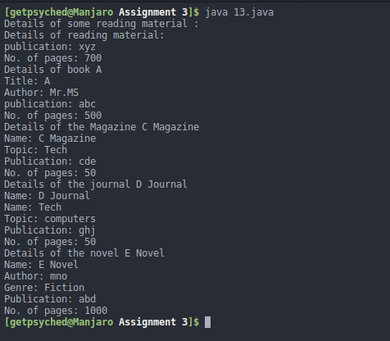

14.
Create class SavingsAccount. Use a static variable annualInterestRate to store the annual interest rate for all account holders. Each object of the class contains a private instance variable savingsBalance indicating the amount the saver currently has on deposit. Provide method calculateMonthlyInterest to calculate the monthly interest by multiplying the savingsBalance by annualInterestRate divided by 12—this interest should be added to savingsBalance. Provide a static method modifyInterestRate that sets the annualInterestRate to a new value. Write a program to test class SavingsAccount. Instantiate two savingsAccount objects, saver1 and saver2, with balances of `2000.00 and `3000.00, respectively. Set annualInterestRate to 4%, then calculate the monthly interest for each of 12 months and print the new balances for both savers. Next, set the annualInterestRate to 5%, calculate the next month’s interest and print the new balances for both savers.

public class foobar {
static class SavingsAccount{
static float annualInterestRate;
private float savingsBalance;
SavingsAccount(float money) {savingsBalance=money;}
float calculateMonthlyInterest() {
return savingsBalance+=(savingsBalance*annualInterestRate)/12;
}
static void modifyInterestRate(float i) { annualInterestRate = i; }
}

public static void main(String[] args) {
SavingsAccount saver1 = new SavingsAccount(2000);
SavingsAccount saver2 = new SavingsAccount(3000);
saver1.modifyInterestRate(4);
System.out.println("For saver1");
for(int i=0; i < 12; i++)
System.out.println("Balance after "+(i+1)+ " month-->"+saver1.calculateMonthlyInterest());
System.out.println();
System.out.println("For saver2");
for(int i=0; i < 12; i++)
System.out.println("Balance after "+(i+1)+ " month-->"+saver2.calculateMonthlyInterest());
System.out.println("With new interest rate:");
saver1.modifyInterestRate(5);
System.out.println("Balance for saver1 is "+saver1.calculateMonthlyInterest());
System.out.println("Balance for saver2 is "+saver2.calculateMonthlyInterest());
}
}
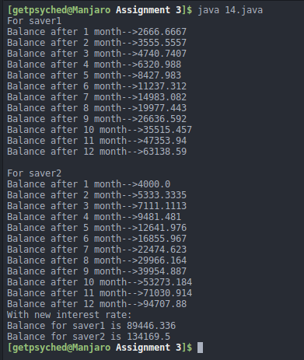

15.
Design a class named StopWatch. The class contains:
 Private data fields startTime and endTime with getter methods.
 A no-arg constructor that initializes startTime with the current time.
 A method named start() that resets the startTime to the current time.
 A method named stop() that sets the endTime to the current time.
 A method named getElapsedTime() that returns the elapsed time for the stopwatch in milliseconds.

Draw the UML diagram for the class and then implement the class in Java.

import java.util.Arrays;
import java.time.LocalTime;

public class foobar {
public static class StopWatch {
long startTime;
long endTime;
public
StopWatch() {
startTime = System.currentTimeMillis();
}
void start() {
startTime = System.currentTimeMillis();
}
void end() {
endTime = System.currentTimeMillis();
}
long getStartTime() {
return startTime;
}
long getEndTime() {
return endTime;
}
long elapsedTime() {
return endTime-startTime;
}
}

public static void main(String[] args) {
int[] randomArray = new int[100000];
System.out.println("Creating an unsorted array of 100,000 numbers");
for (int i = 0; i < randomArray.length; i++)
randomArray[i] = (int) (Math.random() * 100000);
StopWatch s = new StopWatch();
s.start();
Arrays.sort(randomArray);
s.end();
System.out.println("Start time is "+s.getStartTime()+"\nEnd time is "+s.getEndTime()+"\nTime Elapsed is "+ s.elapsedTime());
}
}
